**Introduction to Yoga and Physiology**

**A** **Project** **Report**

Submitted in partial fulfilment of the requirements for the award of degree of:

**Bachelors of technology (computer science and engineering)**

**Submitted** **to**

**LOVELY** **PROFESSIONAL** **UNIVERSITY**

**PHAGWARA,** **PUNJAB**

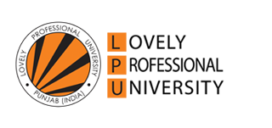

**From** **04/dd/2020 to** **08/dd/2020**

**Submitted** **By:**

**Name: Krati Garg**

**Registration Number: 11913716**

**Signature of the student:**



**Student Declaration:**

**To** **whom** **so** **ever** **it** **may** **concern**

I, **Krati Garg,** hereby declare that the work done by me on “**Introduction to Yoga and Physiology**” from **April, 2020** to **August, 2020**, is a record of original work for the partial fulfilment of the requirements for the award of the degree, **B.Tech (CSE).**

Name: Krati Garg

Signature of the student:



Dated: 5/11/2020

**Certificate for completing the course:**

**Table of content:** Page no.

**Chapter 1: The complete description of the project 5**

1. Description of the project undertaken. 5
2. Introduction of the course. 6
3. Objectives of the course. 7

**Chapter – 2: Course Work - I 8**

1. Introduction of the topics in every week(week 1 to week 3)
2. Brief description.
3. Learning objectives.
4. Work done in every week.

**Chapter – 3: Course Work – II 18**

1. Introduction of the topics in every week(week 4 to week 6)
2. Brief description.
3. Learning objectives.
4. Work done in every week.
5. Challenges faced and how those were tackled. **29**
6. Quizzes with grades. **31**

**Chapter - 4: Conclusion 32**

1. Conclusion.
2. References. **36**

CHAPTER – 1

**The complete description of the project.**

1. **Description of the project undertaken.**

To complete the community development project for the course MGN231, I had chosen a massive open online course according to the option no. 2 of announcement (Regarding the community development projects) dated on 24 April 2020.

I started the course from the month of May 2020 and completed it in the month of august 2020.

The course I had chosen was “Engineering Health: Introduction to Yoga and Physiology” by the New York University on the coursera platform. This course was divided into 6 weeks and it comprised of almost 52 hours. The weekly course assignment includes physiology lectures, a weekly yoga practice, suggested readings, and optional discussions for a total of 3-5 hours per week. The name of the instructors for this are:

1. **Alexandra Seidenstein**, Lecturer, Research Scientist, Yoga Instructor
2. **Eddie Stern**, Yoga Instructor and Author
3. **Tommy Lee**, Senior Lecturer

I selected this course as I wanted to gain some knowledge about physiological systems from the perspective of overall health and wellness and this was also a golden chance for me through the community development project to pursue such a course.

Every module in the course consisted of some practice quizzes and some compulsory quizzes to successfully pass the particular week. There were also some Peer graded assignments on the weekly topics in which we had to write 100-150 words on the given topic and later on it was evaluated by the peers who were also perusing the course in the same time span and at last after completing all the quizzes and peer graded assignment successfully with the required grades I got the certificate of completion.

1. **Introduction of the course:**

This course gives us access to an exploration of physiological systems from the perspective of overall health and wellness. In particular, a focus on yoga, meditation and mindfulness as a therapeutic intervention in chronic illness and long term treatment.

**Yoga: Yoga** is essentially a spiritual discipline based on an extremely subtle science, which focuses on bringing harmony between mind and body. ... The word '**Yoga**' is derived from the Sanskrit root 'Yuj', meaning 'to join' or 'to yoke' or 'to unite'.

**Physiology**: **Physiology** is the science of the mechanical, physical, and biochemical function of humans, and serves as the foundation of modern medicine. As a discipline, it connects science, medicine, and health, and creates a framework for understanding how the human body adapts to stresses, physical activity, and disease.

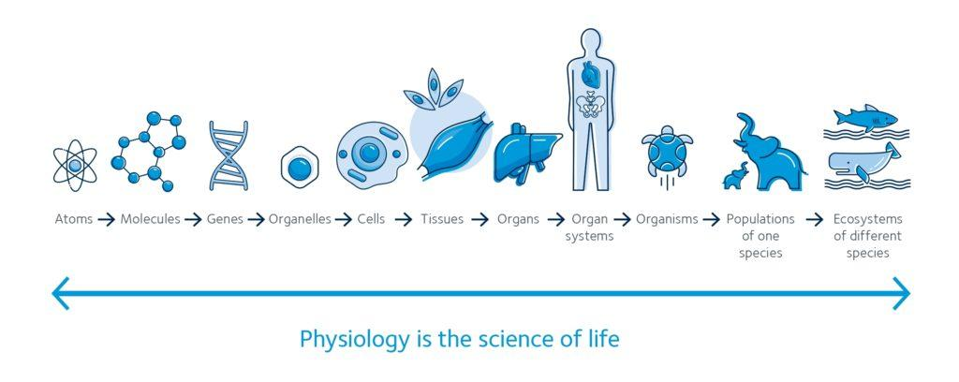

In summary, when one completes this course one can: -

* Learn that yoga can help in reducing stress, and aiding in healing or preventing physiological pathologies.
* Learn about different physiological systems.
* Yoga practices that can influence different systems and reduce pathology.
* Also access the free E-book that comes as a complement with this course.

These are some major objectives, in spite of this every module has a very wide range of objectives.

**3. Objectives of the course:**

Throughout this course, we will learn about different physiological systems and highlight yoga practices that can influence different systems and reduce pathology. Reading material includes analysis of scientific studies that have successfully utilized yoga practice as a tool for treatment of various illnesses such as: hypertension, stress, diabetes, insomnia, chronic pain and PTSD.

The value of taking this course is to understand the impact that yoga can have on reducing stress, and aiding in healing or preventing physiological pathologies. This course is intended for yoga practitioners and teachers, as well as college students and medical practitioners looking for a deeper understanding of the physiological benefits of yoga.

Learning objectives of the course are:

* First we have to understand two main terms:
* What is Yoga?
* What is physiology?
* Then we will learn the following :
  + Describe how yoga might impact physiology.
  + Reasons why yogis and yogi teachers will benefit from a knowledge and application of physiologic concepts.
  + How yoga can help in keeping us physically and mentally.
  + Depth scientific understanding of this ancient healing method.

CHAPTER – 2

**Course Work - I**

1. **Introduction of the topic in each week:**

This course was basically divided into 6 weeks, each consisting of different topics, assignments and quizzes.

So, here are the descriptions about each topic covered in every week.

Week – 1: **The cell and homeostasis**

**Brief description**: The focus of this module is to provide a basic understanding to the workings of the trillions of cells that make up our body. The lecture provides an overview of the functioning components of the cell, energy production and signaling network of our cells. This gives us the ability to understand how cells work, and their purpose to understand cell stress and related pathologies. The yoga component of this module introduces the basics to the practice to allow us to begin building healthier cell programming and reducing cellular stress.

**Objective**:

* Identify conditions for proper cell functioning
* Relate function of cells to overall health
* Identify the function, role and structure of cells.

**Lesson 1: Overall Cell Health**

**Cell Health:**

Our bodies are made up of about a hundred million(100,000,000,000,000) tiny cells. You can only see them under a microscope.

Cells group themselves together to make up the tissues and organs of our bodies.

Body tissues grow by increasing the number of cells that make them up. Cells in many tissues in the body divide and grow very quickly.

When cells become damaged or die the body makes new cells to replace them. This process is called cell division. Normal growth and healing is well ordered and precise. Cells send chemical messages to each other so that they stop growing and dividing when growth or healing is complete. 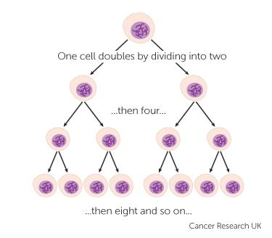

When cells become damaged or worn out, they self-destruct. This is called apoptosis. It helps to protect us from developing cancer. Cells can also undergo apoptosis if they have broken away from their proper place in the body.

**Cell signaling and stress:**

Cells signal to other cells. There are organisms like bacteria that are individual cells, but

we of course are not. We are made of trillions of cells that all have to go through a regulatory process and work together to actually carry out functions as tissues and organs and whole organisms. So regulatory signals, environmental signals, such as outside of our bodies or

even outside of our cells, we're constantly receiving signals. We're going to get signals to different types of cells, We're going to do things like repair, right?

We repair cells on a physiological level, if we cut our cells or have a torn muscle, but on a cellular level as well. One of the classic examples of cell signaling is between two neurons and one of the most important parts of implementing a new practice whether it be yoga, constant exercise, healthy positive thinking, mindfulness, meditation, is that cells are constantly turning over.

So they are repairing themselves if they're damaged, but a large majority of our cells are also going to be creating new cells every second, every day, every year. Such as skin cells, right, skin cells are the easiest cells for us to imagine turning over because you probably can imagine if you rub your skin really hard, you'll see actual dead skin cells move away. It's estimated that we lose about nine pounds per year of skin cells and there's about 22 billion per night made. And when we start to calculate all of this together with all of our cells, what this means is sometime next year you will wake up and you will be in a 95% new body which means if you want that new body to be optimal health and feel different there's a lot of things we can do over time to start to promote healthier cell development. So cells are changing at a very, very, very fast rate and the cumulative effects of this is very profound.

**Lesson 2: Yoga to aid in maintaining homeostasis**

**Yoga and our cell system:**

Moving to the floor, we do a lying down sun salutation, expanding the lungs and rib cage, and stretching the spine. This is followed by a core strengthening pose, similar to a crunch, but a smaller and gentler version. The final pose in the sequence is a digestive strengthening pose, as well as balancing for the spine. To close, we rest in savasana. In this mindfulness practice we will learn the “body scan,” in which we will mentally draw our awareness to every part of your body, relaxing each part in turn. When the body is relaxed, the mind also slows down, and the nervous system enters into a state of rest. This is beneficial for our entire body, which is an interconnected cellular environment.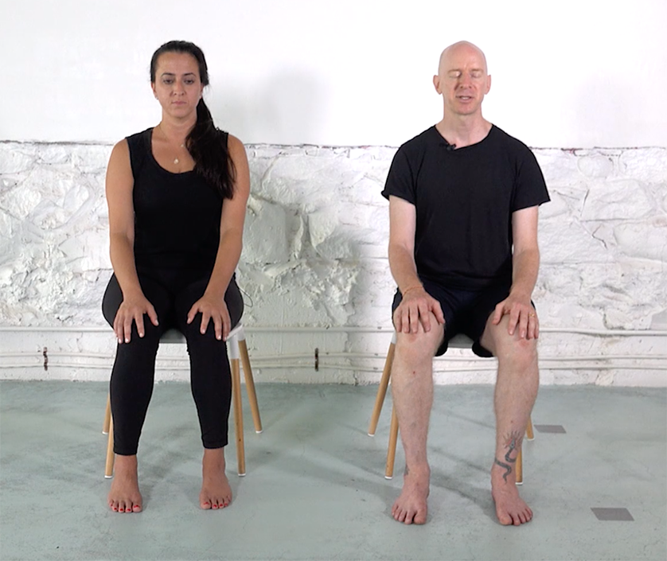

**Seated movements in a chair:** This seated practice is something that you can do pretty much anywhere: at home, at the office, in a subway (if it’s kind of empty), or in a plane. We start with all of the basic movements that the spine can move in:

1. Extension, which is demonstrated by stretching the arms up one by one.
2. Rounding and arching of the spine, as in the seated cat/cow.
3. Twisting, shown left to right.
4. Lateral, shown in the side bend movement, to the left and right.
5. Extension and flexion of the neck.
6. Extended twist and open, using the arms as leverage.
7. The upper back stretches in the cactus arms.

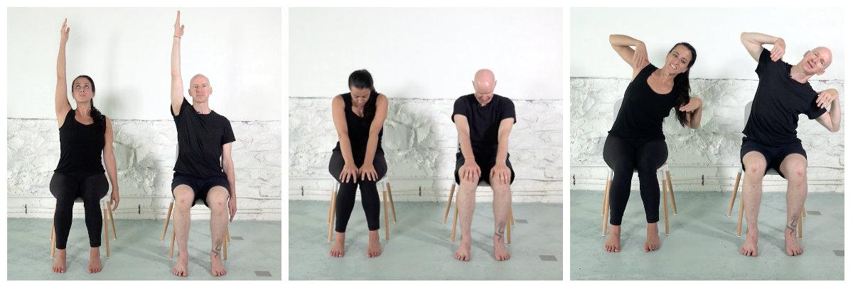

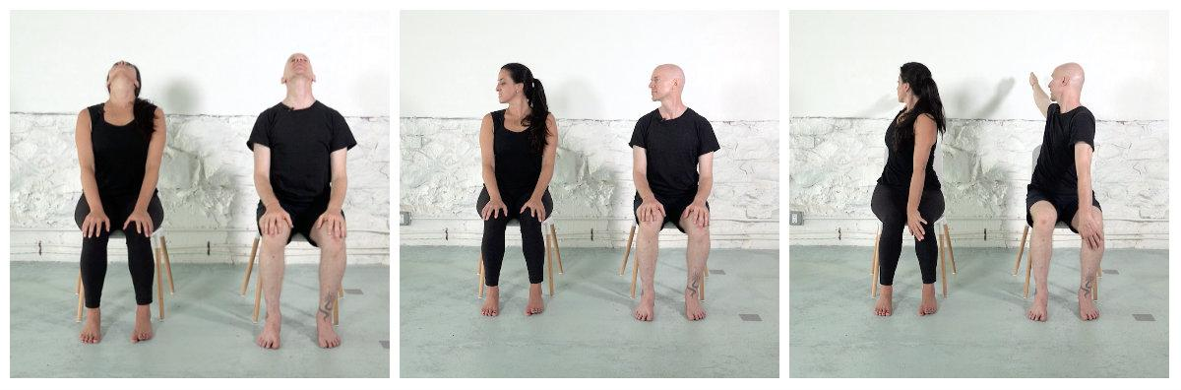

**Chair yoga and mindful movement**: One of the things that we're gonna be thinking about are the different functions of homeostasis and how movement and breathing is going to support homeostasis. So one of the biggest ways that breathing can help homeostasis is with gas exchange, which is really crucial for not only oxygen in our tissues and exchanging for carbon dioxide, but it also helps to regulate PH and therefore also regulates the rate of breathing.

Homeostasis is important for things like temperature control, for stress management, for making proteins, for regulating any mutations or errors with our DNA. It helps to maintain metabolic functions or sugar levels and a long list of other things.

**Lesson 3: The cell and homeostasis(summary)**

**Summary-Yoga to create cell health:**

The focus of this module is to identify the foundational functions of the cells, and their overall processes in maintaining homeostasis. In doing so, we look at the interconnected nature of our cells and their role in maintaining physiological health is explored. Recognition of the impact that cell stress can have on our bodies, helps with understanding why practices such as yoga and meditation are so crucial. In the practice component of this module, the yoga is started slow and approachable, with practices both on the floor and in a chair.



Week – 2: **Genetics**

**Brief description**: This module defines the basics of genetics in exploration of contributing factors to healthy chromosomes and genetic regulation. By explaining the role that stress can have on cells and chromosomal wellbeing, we provide a foundation for understanding how epigenetics can be affected by repetition and being to help to promote new regulatory factors.

**Objective**:

* Describe the basics of human genetics and chromosomes
* Describe the field of epigenetics, and the role of environment on health
* Explain how repetition can help influence epigenetics and gene expression

**Lesson 1: An overview of Genetics**

A gene is defined as a *unit of inheritance*. In more laymen’s terms genes can be likened to words in a book that are made up of letters. Just as letters are made of specific ink strokes, genes are made up a specific set of molecules: a sugar, a phosphate and a base. This detail is important because the sugar and phosphate are always the same but the base has 4 choices.

Every night, every 24 hours, our cells (those that can divide, like skin cells) create about 22 billion new cells. We lose about 40,000 skin cells per day, There is such tremendous work and change which happens at a cellular level, that this time next year you will wake up in a 95% different body then what you have this second. Factors such as diet, exercise, sleep, and stress matter; and will shape the majority of the difference between the body you are sitting in now, and the one next year. But here is the really miraculous thing to drive it all home, every cell in our body (excluding red blood cells because they have no DNA or genetic material), carry the same genetic material, What is it that genes actually have instructions to make? The answer is proteins, and that's it. Which means proteins are a big category of macromolecules and they include a huge list of different types of things in a cell (some of these words you might recognize, some not , but the important thing is that proteins have range): microtubules, enzymes, receptors, histones, keratin, myosin, actin, collagen, fibronectin, clotting factors, calcium/potassium/sodium channels, glucose transporters, immunoglobulins, and the list goes on. Ok so proteins are important and we build them by looking at the genes for instructions. In genetics terms this is The Central Dogma and it says: DNA makes RNA which then makes Amino Acids that get strung together and begin the process of making a protein or DNA makes more DNA, and that's it.

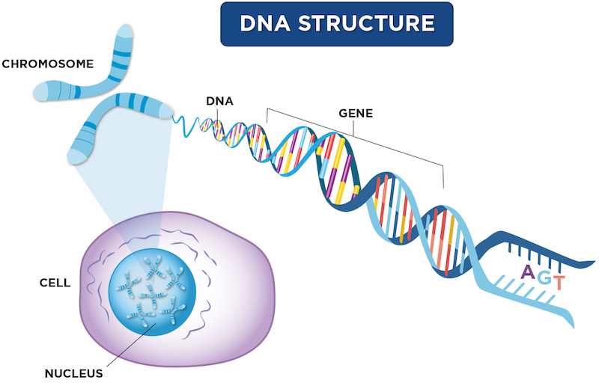

Epigenetics plays an important role. If we attached molecules to our bases they can help to tell the cells where there is relevant info, how much of the protein from a gene to make, and which proteins are the most important for the cell etc.

**Lesson 2: Nervous system physiology**

Nervous System and Neurotransmitters:

Fibers called nerves carry important messages back and forth between your body and your brain. That network -- your nervous system -- has two parts:

* Your brain and spinal cord make up your central nervous system.
* The nerves in the rest of your body make up your peripheral nervous system.

Everything your body does is connected in some way to your nervous system. It tells your heart to beat. It tells your lungs to breathe. It controls the way you move, the words you say, and how you think and learn. It also controls your senses and memories.

The messages traveling in your nerves are sent through billions of nerve cells called neurons. The spaces between these cells are called synapses. The cells are linked to one another through chemicals called neurotransmitters that move across the synapses to the next neuron. Dopamine and serotonin are types of neurotransmitters. This process continues until the message gets to the right place. Some messages move faster than 200 miles per hour. This is also how messages get from your body back to your brain and spinal cord. For example, if you step on something sharp, the nerves in your foot send a message from neuron to neuron to your central nervous system that says, Hey, this hurts. Your brain and spinal cord respond with a message to your foot: Pull away now.

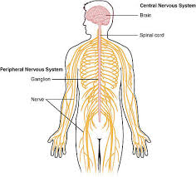

How Can I Keep My Nervous System Healthy?

Just like other parts of your body, your brain needs sleep for rest and repair, so a good regular sleep schedule is key. A healthy balanced diet that features foods high in omega-3 fatty acids is important, too. Those include fatty fish like salmon, albacore tuna, mackerel, herring, and farmed trout.

Stress also can affect your nervous system, but you can do a few things to manage it:

* Exercise regularly
* Give yourself permission to take a break
* Spend quality time with family and friends
* Meditate or practice mindfulness with yoga or other activities

Neurotransmitters: Neurotransmitter, also called chemical transmitter or chemical messenger, any of a group of chemical agents released by neurons (nerve cells) to stimulate neighbouring neurons or muscle or gland cells, thus allowing impulses to be passed from one cell to the next throughout the nervous system.

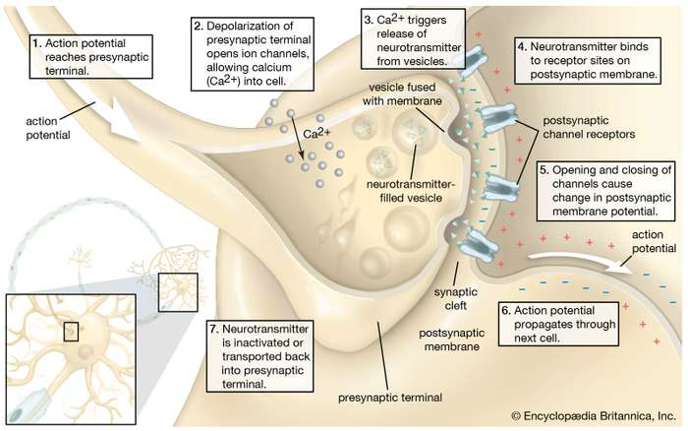

Most of the neurotransmitters are about the size of a single amino acid; however, some neurotransmitters may be the size of larger proteins or peptides. A released neurotransmitter is typically available in the synaptic cleft for a short time before it is metabolized by enzymes, pulled back into the presynaptic neuron through reuptake, or bound to a postsynaptic receptor. Nevertheless, short-term exposure of the receptor to a neurotransmitter is typically sufficient for causing a postsynaptic response by way of synaptic transmission.

Generally, a neurotransmitter is released at the presynaptic terminal in response to a threshold action potential or graded electrical potential in the presynaptic neuron. However, low level 'baseline' release also occurs without electrical stimulation.

**Lesson 3: Summary of Week 2**

Genetics: During this module we learned the basics of genetics, with focus on genetic regulation that can be impacted and changed. Epigenetics was highlighted in order to understand how the course of our lives can have an impact on a genetic level. Although epigenetics is a relatively new branch of genetics, there are a number of studies that are showing epigenetic changes in response to life, exercise, disease, stress, and many other factors. Utilizing what we know about epigenetic changes, we implement yoga techniques to start to build a consistent yoga practice, with the intention of repeating the practice over time.

Nervous System: In this model we take a general look at the Nervous System from a cellular level to the branching of the categories of the NS, and regions of the brain. In doing so we begin to build an understanding of how conscious breathing and movement can aid in regulating our nervous system by decreasing overactivity of the sympathetic system. In addition, this module utilizes our foundational understanding of the major neurological components of back pain and how yoga can aid in prevention and treatment of back pain. By exploring some exercises that help relieve back pain by focusing on the abdominal muscles, as well as the posterior chain, and associated muscles, we begin to promote healthy spine health through breath and movement.

Week – 3: **The Respiratory System**

**Brief description**: This module presents an overview of the respiratory system including both the molecular functioning as well as the overall mechanisms of breathing. In understanding how and why we breathe, we will have a deeper understanding of the role that breathing has in stress reduction, physiological well being and overall health. The yoga component of this lesson will focus on different breathing techniques that can be utilized to optimize wellness.

**Objective**:

* Identify the role, function, and basic structure of the respiratory system
* Explain gas exchange on a cellular level
* Describe how breath exercise promotes proper circulation and gas exchange
* Practice breath exercise that promotes proper circulation and gas exchange

**Lesson 1: Intro to the Respiratory System**

Human respiratory system, the system in humans that takes up oxygen and expels carbon dioxide.

The human gas-exchanging organ, the lung, is located in the thorax, where its delicate tissues are protected by the bony and muscular thoracic cage. The lung provides the tissues of the human body with a continuous flow of oxygen and clears the blood of the gaseous waste product, carbon dioxide. Atmospheric air is pumped in and out regularly through a system of pipes, called conducting airways, which join the gas-exchange region with the outside of the body. The airways can be divided into upper and lower airway systems. The transition between the two systems is located where the pathways of the respiratory and digestive systems cross, just at the top of the larynx.

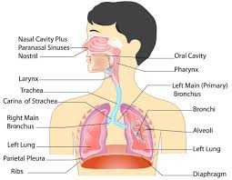

The upper airway system comprises the nose and the paranasal cavities (or sinuses), the pharynx (or throat), and partly also the oral cavity, since it may be used for breathing. The lower airway system consists of the larynx, the trachea, the stem bronchi, and all the airways ramifying intensively within the lungs, such as the intrapulmonary bronchi, the bronchioles, and the alveolar ducts. For respiration, the collaboration of other organ systems is clearly essential. The diaphragm, as the main respiratory muscle, and the intercostal muscles of the chest wall play an essential role by generating, under the control of the central nervous system, the pumping action on the lung. The muscles expand and contract the internal space of the thorax, the bony framework of which is formed by the ribs and the thoracic vertebrae. The contribution of the lung and chest wall (ribs and muscles) to respiration is described below in The mechanics of breathing. The blood, as a carrier for the gases, and the circulatory system (i.e., the heart and the blood vessels) are mandatory elements of a working respiratory system

**Lesson 2: Cardiovascular System**

The heart and circulatory system make up your cardiovascular system.

Your heart works as a pump that pushes blood to the organs, tissues, and cells of your body. Blood delivers oxygen and nutrients to every cell and removes the carbon dioxide and waste products made by those cells. Blood is carried from your heart to the rest of your body through a complex network of arteries, arterioles, and capillaries. Blood is returned to your heart through venules and veins. If all the vessels of this network were laid end to end, they would extend for about 60,000 miles (more than 96,500 kilometers), which is far enough to circle the planet Earth more than twice! 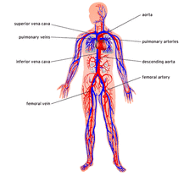

The one-way system carries blood to all parts of your body. This process of blood flow within your body is called circulation. Arteries carry oxygen-rich blood away from your heart, and veins carry oxygen-poor blood back to your heart.

In pulmonary circulation, though, the roles are switched. It is the pulmonary artery that brings oxygen-poor blood into your lungs and the pulmonary vein that brings oxygen-rich blood back to your heart.

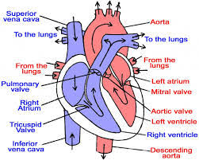

Twenty major arteries make a path through your tissues, where they branch into smaller vessels called arterioles. Arterioles further branch into capillaries, the true deliverers of oxygen and nutrients to your cells. Most capillaries are thinner than a hair. In fact, many are so tiny only one blood cell can move through them at a time. Once the capillaries deliver oxygen and nutrients and pick up carbon dioxide and other waste, they move the blood back through wider vessels called venules. Venules eventually join to form veins, which deliver the blood back to your heart to pick up oxygen.

**Lesson 3: Summary of Week 3**

Respiratory System: This module focused on building a foundational understanding of the respiratory system, on both a molecular level and a macro scale. By discussing anatomy, gas exchange, and aerobic respiration, we are able to comprehend the main functions and purpose of the respiratory system. In addition, we looked at the benefits of deep breathing, and promoting increased oxygenation. The breathing exercises highlight the way we can have an impact on our respiratory system, stress levels and overall health by practicing different breathing techniques.

Cardiovascular System: The focus of this module is understanding the cardiovascular system, both the purpose and the function. By understanding the mechanisms of the heart, the flow of blood through vessels (arteries, veins, capillaries), we have begun to build a foundation to understand the mechanisms behind the cardiovascular system. In doing so, we have the comprehension to learn about associated pathologies. In particular, blood pressure and hypertension are explained. The discussion of blood pressure is enhanced by the interview with Dr. Marshall Hagins about cardiovascular health.

CHAPTER – 3

**Course Work**

Week – 4: **Lymphatic System and Musculoskeletal System**

**Brief description:** The focus of this module is to provide a basic understanding and introduction to the lymphatic and immune systems. The lecture provides an overview of the main components of the lymphatic system; vessels, glands and lymph components. In addition, an overview of the immune system focuses on the primary component. These two interconnected systems are highlighted in order to understand lymph circulation as well as pathologies, such as autoimmune diseases and inflammation. The yoga component of this module focuses on postures that have sweeping movement to increase lymphatic circulation, and ones that promote a calm and healthy immune system.

**Objective**:

* Identify the role, function, and structure of the lymph and immune systems
* Relate lymphatic system function to the cardiovascular system
* Describe how yoga postures promote proper lymph and immune function
* Practice yoga postures that promote proper lymph and immune function

**Lesson 1: Lymphatic and Immune System**

The lymphatic system is part of the immune system. It also maintains fluid balance and plays a role in absorbing fats and fat-soluble nutrients.

The lymphatic or lymph system involves an extensive network of vessels that passes through almost all our tissues to allow for the movement of a fluid called lymph. Lymph circulates through the body in a similar way to blood. There are about 600 lymph nodes in the body. These nodes swell in response to infection, due to a build-up of lymph fluid, bacteria, or other organisms and immune system cells.

The lymphatic system has three main functions:

* It maintains the balance of fluid between the blood and tissues, known as fluid homeostasis.
* It forms part of the body’s immune system and helps defend against bacteria and other intruders.
* It facilitates absorption of fats and fat-soluble nutrients in the digestive system.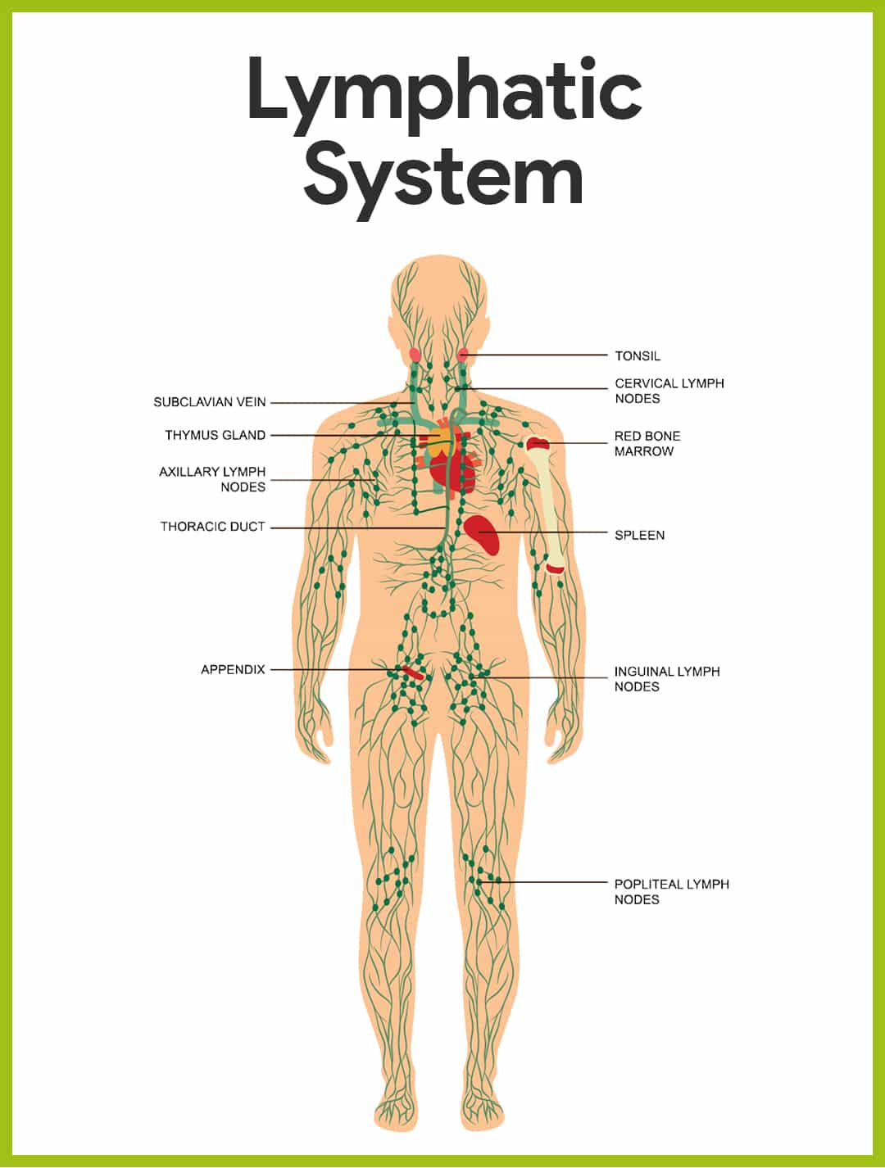

Immune System: Our bodies are constantly exposed to potentially hazardous microorganisms, such as infections.

The body’s first line of defense involves:

* physical barriers, such as the skin
* toxic barriers, such as the acidic contents of the stomach
* “friendly” bacteria in the body

However, pathogens often do succeed in entering the body despite these defenses. In this case, the lymphatic system enables our immune system to respond appropriately.The lymphatic system produces white blood cells, known as lymphocytes. There are two types of lymphocyte, T cells and B cells. They both travel through the lymphatic system.

As they reach the lymph nodes, they are filtered and become activated by contact with viruses, bacteria, foreign particles, and so on in the lymph fluid. From this stage, the pathogens, or invaders, are known as antigens.As the lymphocytes become activated, they form antibodies and start to defend the body. They can also produce antibodies from memory if they have already encountered the specific pathogen in the past.

Collections of lymph nodes are concentrated in the neck, armpits, and groin.

**Lesson 2: Musculoskeletal System**

The human musculoskeletal system (also known as the locomotor system, and previously the activity system) is an organ system that gives humans the ability to move using their muscular and skeletal systems. The musculoskeletal system provides form, support, stability, and movement to the body.

It is made up of the bones of the skeleton, muscles, cartilage, tendons, ligaments, joints, and other connective tissue that supports and binds tissues and organs together. Then musculoskeletal system's primary functions include supporting the body, allowing motion, and protecting vital organs.

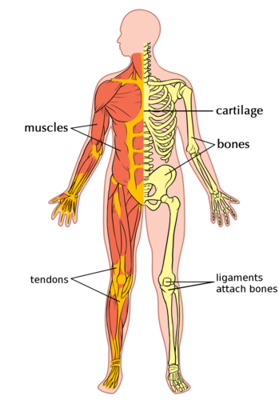 Major Components:

BONE – 206 bones in the adult body that:

- Provide support - Store minerals and lipids - Produce blood cells - Protect visceral organs - Provide movement in conjunction with muscles

TENDON – Tissue that attach muscle to bone

LIGAMENTS – Tissue that attach bone to bone

SKELETAL MUSCLE - striated, multinucleated muscle that contracts to pull on tendons and move bones.

They also: - Support soft tissue - Maintain posture

CARTILAGE – Connective tissue, that is a gel-like that has three main categories: Hyaline (ribs and ends of bones/joints), elastic(ear), and fibrocartilage (knee).

Functionally they: - Provide support - Reduce friction - Resist compression forces

NERVES– Synapse onto skeletal muscle and stimulate the contraction of muscle, and therefore movement of bones.

JOINTS - Location where two bones intersect. They must allow for both stability and range of motion, depending on their location and weight bearing requirements.

**Lesson 3: Summary of Week 4**

Lymphatic System: The focus of this module is identifying the main structures and functions of the lymphatic and immune systems. The mechanisms of lymph vessels, components and functions, help with understanding inflammation and autoimmune disease. In addition, the difference between cardiac and lymphatic circulation is discussed to compare types of circulation in our bodies. In the practice component of this module, the yoga looks at inversions via sun salutations, as well as postures that put pressure on lymphatic vessels to aid with flow and drainage, decreasing stress, and reducing inflammation.

Musculoskeletal System: This module allowed us to take a deep look at the physiology of the musculoskeletal system, on both a micro and macro scale. We learned the major components of this system, in addition to the molecular structure and functioning of skeletal muscle. We looked at bones and vertebral column, focusing on posture and alignment. Dr. Seidenstein highlighted ligaments and tendon, as well as, explored some common injuries he sees to the musculoskeletal systems. His interview highlighted the reasons that the American Academy of Orthopedic Surgery endorses yoga as an important preventative and treatment modality for musculoskeletal injuries.

Week – 5: **The Renal System**

**Brief description:** The focus of this module is to provide a basic understanding and introduction to the renal system and highlight other excretory systems. The lecture provides an overview of the functioning components of the renal system, the nephrons. The ability to understand how nephrons work, and their purpose to understand pathologies, such as high blood pressure. The yoga component of this module focuses on forward and back bends that have the ability to promote kidney health.

**Objective**:

* Identify the role, function, and structure of the renal system
* Describe how yoga and stress influence kidney function
* Practice yoga poses and movements that promote kidney health and awareness

**Lesson 1: Introduction to Renal System**

Renal system, in humans, organ system that includes the kidneys, where urine is produced, and the ureters, bladder, and urethra for the passage, storage, and voiding of urine.

In many respects the human excretory, or urinary, system resembles those of other mammalian species, but it has its own unique structural and functional characteristics. The terms excretory and urinary emphasize the elimination function of the system. The kidneys, however, both secrete and actively retain within the body certain substances that are as critical to survival as those that are eliminated.

The system contains two kidneys, which control the electrolyte composition of the blood and eliminate dissolved waste products and excess amounts of other substances from the blood; the latter substances are excreted in the urine, which passes from the kidneys to the bladder by way of two thin muscular tubes called the ureters. The bladder is a sac that holds the urine until it is eliminated through the urethra.

The kidneys: The kidneys are bean-shaped, reddish brown paired organs, concave on one long side and convex on the opposite. They are normally located high in the abdominal cavity and against its back wall, lying on either side of the vertebral column between the levels of the 12th thoracic and third lumbar vertebrae, and outside the peritoneum, the membrane that lines the abdomen.

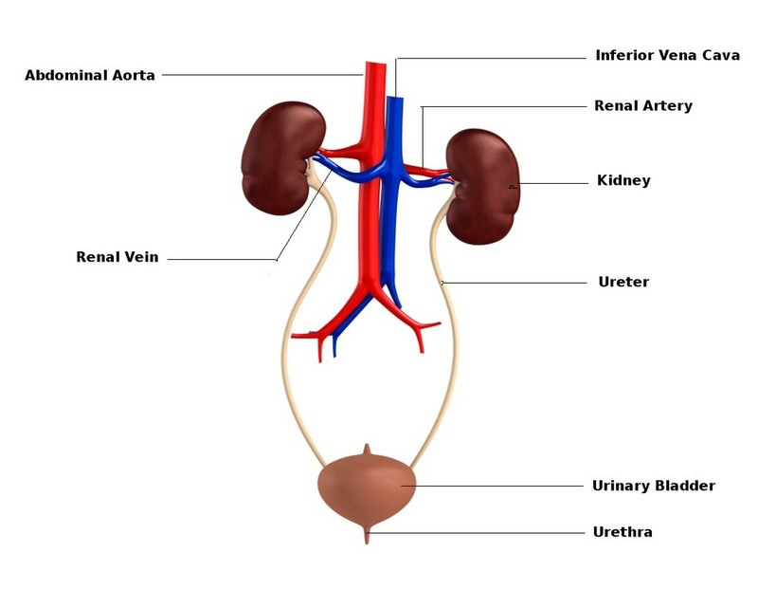

The long axes of the kidneys are aligned with that of the body, but the upper end of each kidney (pole) is tilted slightly inward toward the backbone (vertebral column). Situated in the middle of the medial concave border is a deep vertical cleft, the hilus, which leads to a cavity within the kidney known as the renal (kidney) sinus. The hilus is the point of entry and exit of the renal arteries and veins, lymphatic vessels, nerves, and the enlarged upper extension of the ureters.

**Lesson 2: Digestive System**

The digestive system includes the digestive tract and its accessory organs, which process food into molecules that can be absorbed and utilized by the cells of the body. Food is broken down, bit by bit, until the molecules are small enough to be absorbed and the waste products are eliminated. The digestive tract, also called the alimentary canal or gastrointestinal (GI) tract, consists of a long continuous tube that extends from the mouth to the anus. It includes the mouth, pharynx, esophagus, stomach, small intestine, and large intestine. The tongue and teeth are accessory structures located in the mouth. The salivary glands, liver, gallbladder, and pancreas are major accessory organs that have a role in digestion. These organs secrete fluids into the digestive tract.

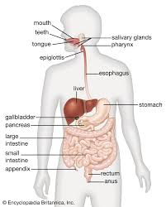

Food undergoes three types of processes in the body: Digestion - Absorption - Elimination

Digestion and absorption occur in the digestive tract. After the nutrients are absorbed, they are available to all cells in the body and are utilized by the body cells in metabolism.

The digestive system prepares nutrients for utilization by body cells through six activities:

Ingestion- The first activity of the digestive system is to take in food through the mouth. This process, called ingestion, has to take place before anything else can happen.

Mechanical Digestion- The large pieces of food that are ingested have to be broken into smaller particles that can be acted upon by various enzymes. This is mechanical digestion, which begins in the mouth with chewing or mastication and continues with churning and mixing actions in the stomach.

Chemical Digestion- The complex molecules of carbohydrates, proteins, and fats are transformed by chemical digestion into smaller molecules that can be absorbed and utilized by the cells. Chemical digestion, through a process called hydrolysis, uses water and digestive enzymes to break down the complex molecules. Digestive enzymes speed up the hydrolysis process, which is otherwise very slow.

Movements- After ingestion and mastication, the food particles move from the mouth into the pharynx, then into the esophagus. This movement is deglutition, or swallowing. Mixing movements occur in the stomach as a result of smooth muscle contraction. These repetitive contractions usually occur in small segments of the digestive tract and mix the food particles with enzymes and other fluids. The movements that propel the food particles through the digestive tract are called peristalsis. These are rhythmic waves of contractions that move the food particles through the various regions in which mechanical and chemical digestion takes place.

Absorption- The simple molecules that result from chemical digestion pass through cell membranes of the lining in the small intestine into the blood or lymph capillaries. This process is called absorption.

Elimination- The food molecules that cannot be digested or absorbed need to be eliminated from the body. The removal of indigestible wastes through the anus, in the form of feces, is defecation or elimination.

**Lesson 3: Summary of Week 5**

Renal System: The focus of this module is identifying the function of the kidneys, and their overall purpose. In doing so, we look at the structures and functions of the nephron, and how they are able to filter the blood. The mechanisms of nephron and its role in blood pressure regulation, helps with understanding high blood pressure and kidney disease. In addition, identifying the other three excretory system, we gain a larger perspective of the importance of excretion. In the practice component of this module, the yoga looks at forward bending and back bends, and putting these into a complete short practice to promote renal health.

Digestive System: The purpose of this module is to provide an overview of the organs and functions of the digestive system. By understanding the major digestive organs and the secondary organs, we are able to better explore promoting and maintaining healthy digestion. The lecture also focuses on two pathologies that have been proven to be aided by yoga and meditation: diabetes and irritable bowel syndrome. In the yoga module we present and practice some of the postures that have been successful in helping reduce symptoms of IBS, improve Diabetes and create a healthier digestive system.

Week – 6: **The Endocrine and Reproductive system**

**Brief description:** The focus of this module is to provide a basic understanding of the endocrine and the reproductive system. The lecture provides an overview of the main components of the endocrine system; hormones, glands and tissues/organs that are affected. In order to understand associated pathologies, specific hormones are highlighted in the class. In addition, the module goes over impact of long term stress with an in depth description of the HPA Axis. The yoga component of this module focuses on relaxing movement to decrease stress and promote a healthy endocrine system.

**Objective**:

* Identify the role, function, and structure of the endocrine and reproductive systems
* Relate reproductive system function to the endocrine system
* Describe stress-reduction techniques that target hormone regulation
* Describe the conditions for which yoga may or may not be considered beneficial for the reproductive health
* Practice stress-reduction techniques that target hormone regulation
* Practice yoga that addresses proper reproductive function

**Lesson 1: The Endocrine system**

The endocrine system is a series of glands that produce and secrete hormones that the body uses for a wide range of functions. These control many different bodily functions, including:

* Respiration
* Metabolism
* Reproduction
* Sensory perception
* Movement
* Sexual development

Hormones are produced by glands and sent into the bloodstream to the various tissues in the body. They send signals to those tissues to tell them what they are supposed to do. When the glands do not produce the right amount of hormones, diseases develop that can affect many aspects of life.

THE MAIN HORMONE-PRODUCING GLANDS ARE:

* [Hypothalamus](https://www.hormone.org/your-health-and-hormones/glands-and-hormones-a-to-z/glands/hypothalamus): The hypothalamus is responsible for body temperature, hunger, moods and the release of hormones from other glands; and also controls thirst, sleep and sex drive.
* [Pituitary](https://www.hormone.org/your-health-and-hormones/glands-and-hormones-a-to-z/glands/pituitary-gland): Considered the "master control gland," the pituitary gland controls other glands and makes the hormones that trigger growth.
* [Parathyroid](https://www.hormone.org/your-health-and-hormones/glands-and-hormones-a-to-z/glands/parathyroid): This gland controls the amount of calcium in the body.
* [Pancreas](https://www.hormone.org/your-health-and-hormones/glands-and-hormones-a-to-z/glands/pancreas): This gland produces the insulin that helps control blood sugar levels.
* [Thyroid](https://www.hormone.org/your-health-and-hormones/glands-and-hormones-a-to-z/glands/thyroid): The thyroid produces hormones associated with calorie burning and heart rate.
* [Adrenal](https://www.hormone.org/your-health-and-hormones/glands-and-hormones-a-to-z/glands/adrenal-glands): Adrenal glands produce the hormones that control sex drive and cortisol, the stress hormone.
* [Pineal](https://www.hormone.org/your-health-and-hormones/glands-and-hormones-a-to-z/glands/pineal-gland): This gland produces melatonin which affect sleep.
* [Ovaries](https://www.hormone.org/your-health-and-hormones/glands-and-hormones-a-to-z/glands/ovaries): Only in women, the ovaries secrete estrogen, testosterone and progesterone, the female sex hormones.
* [Testes](https://www.hormone.org/your-health-and-hormones/glands-and-hormones-a-to-z/glands/testes): Only in men, the testes produce the male sex hormone, testosterone, and produce sperm.

Some of the factors that affect endocrine organs include aging, certain diseases and conditions, stress, the environment, and genetics.

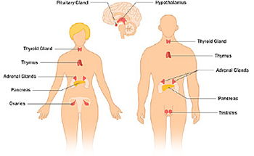

**Lesson 2: the Reproductive System**

The Human reproductive system is comprised of organs and glands that work with hormones to carry out sexual reproduction, where a combination of genetic material between two individuals creates a more genetically diverse offspring. This process includes the creation of gametes, sperm in men and ovum (egg) in women. Both types of gametes are created through a multi stage process driven by hormones and results in a cell that has half of the genetic material. Upon fertilization, the new embryo (being a fusion of sperm and egg) regains the

complete genetic material (46 chromosomes).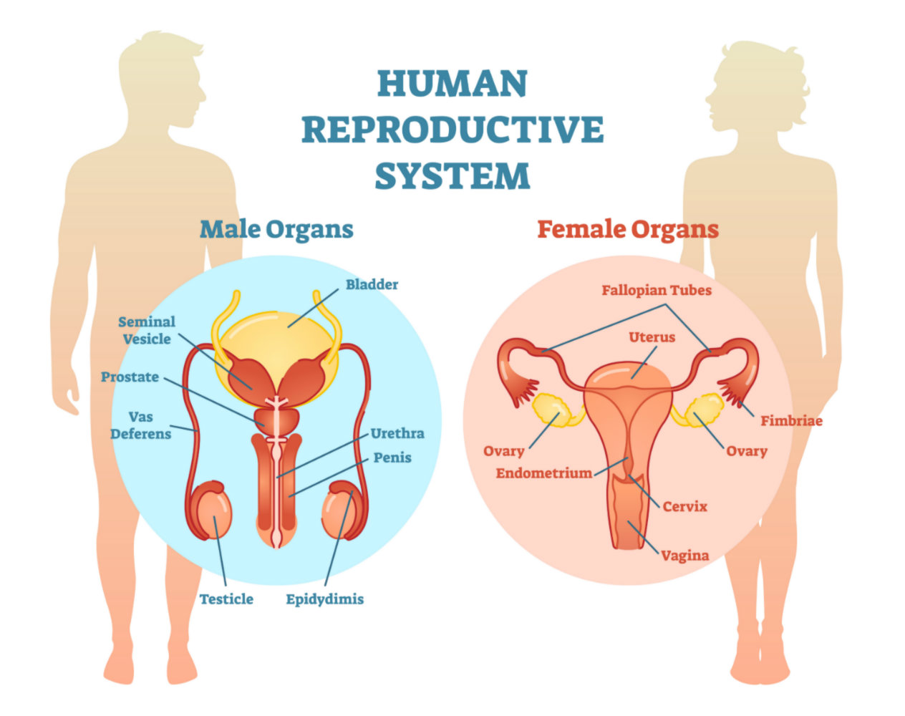

**Male Reproductive System**

The creation of sperm is carried out through a process called spermatogenesis via meiosis (cell division) after puberty at a rate of about 1500 sperm per second.njkhkhiohiooioiyih88bhbhjgy Male primary reproductive organs can be categorized by function:

1. Sperm synthesis and storage: testes, scrotum and epididymis
2. Ejaculatory fluid: Cowper’s Gland, seminal vesicles, prostate and vas deferens
3. Sperm deposition: penis, urethra, and vas deferens

Male secondary sexual characteristics include: muscular stature, lower and deeper voice, increase facial and body hair, and Adam’s apple.

**Female Reproductive System**

The creation of female gametes occurs during a process called oogenesis via meiosis, and unlike spermatogenesis, it begins at birth. Primary oocytes (immature eggs) are present at birth, and the final stages of egg production occur during the menstrual cycle after puberty. Every month, a series of hormones: Luteinizing hormone (LH), Follicle-Stimulating Hormone (FSH), estrogen, and progesterone, regulate ovulation and the phases of the menstrual cycle At around every 28 days, the pituitary gland releases FSH to stimulate ova production, which is followed by other hormonal changes and regulations. The menstrual cycle develops one (or possibly more) ova that can be fertilized during the ovulation phase of the menstrual cycle.

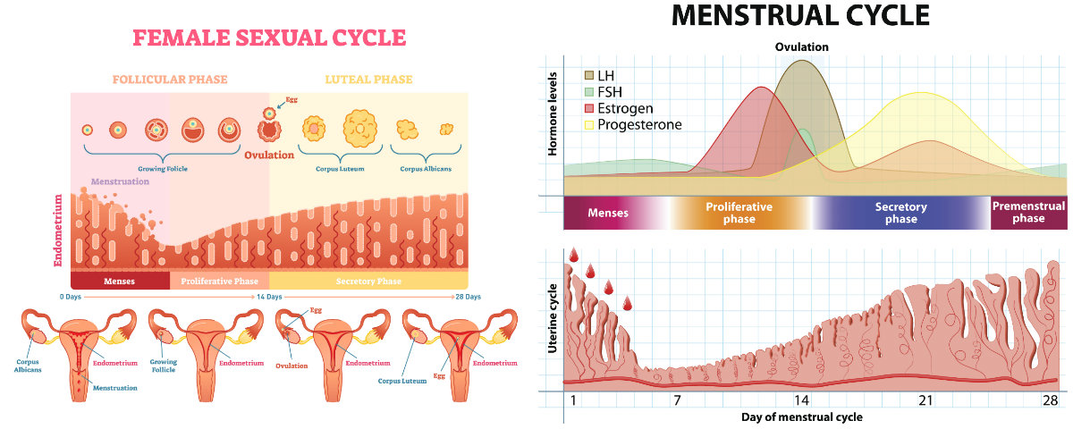

Female primary reproductive system organs contain three main parts located inside the body in the pelvic regions:

1. Vulva: Leading to the vagina
2. Uterus: Will hold the developing fetus
3. Ovaries: Produce the va (Egg cells)

Female secondary characteristics, such as breast development and hip widening, are created to favor optimal conditions for pregnancy and maternal care of offspring.

If the sperm and ovum are fertilized a zygote (fertilized egg) is created and implanted, the rapid cellular division and development and human embryonic development ensues over the next 9 months.

**Lesson 3: Yoga and the Endocrine system**

In this lesson we learned about several poses that are calming, soothing, and relaxing for the endocrine system and de-stressing.

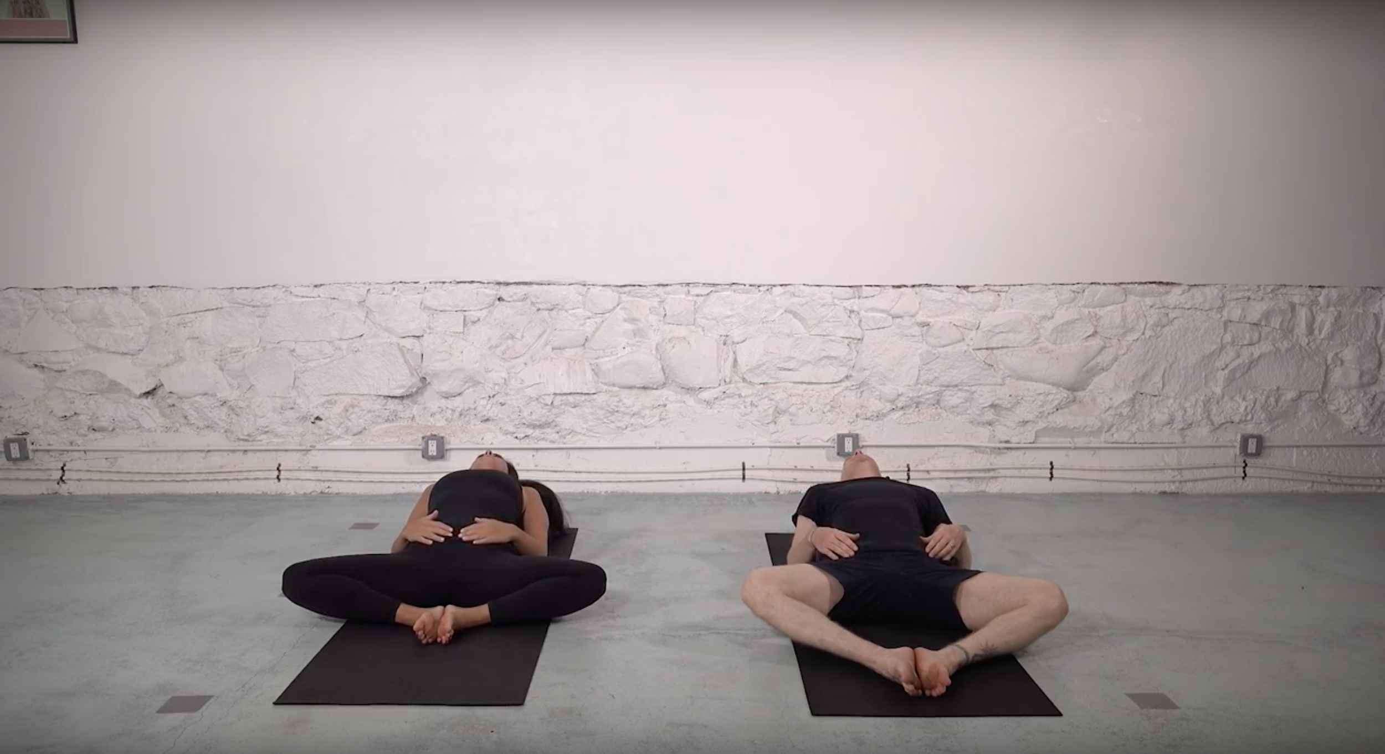

The first pose is done by making a slope of pillows or cushions, bending your knees and bringing the soles of your feet together, and then laying back over the pillows in a relaxed manner. Make sure your head is supported.

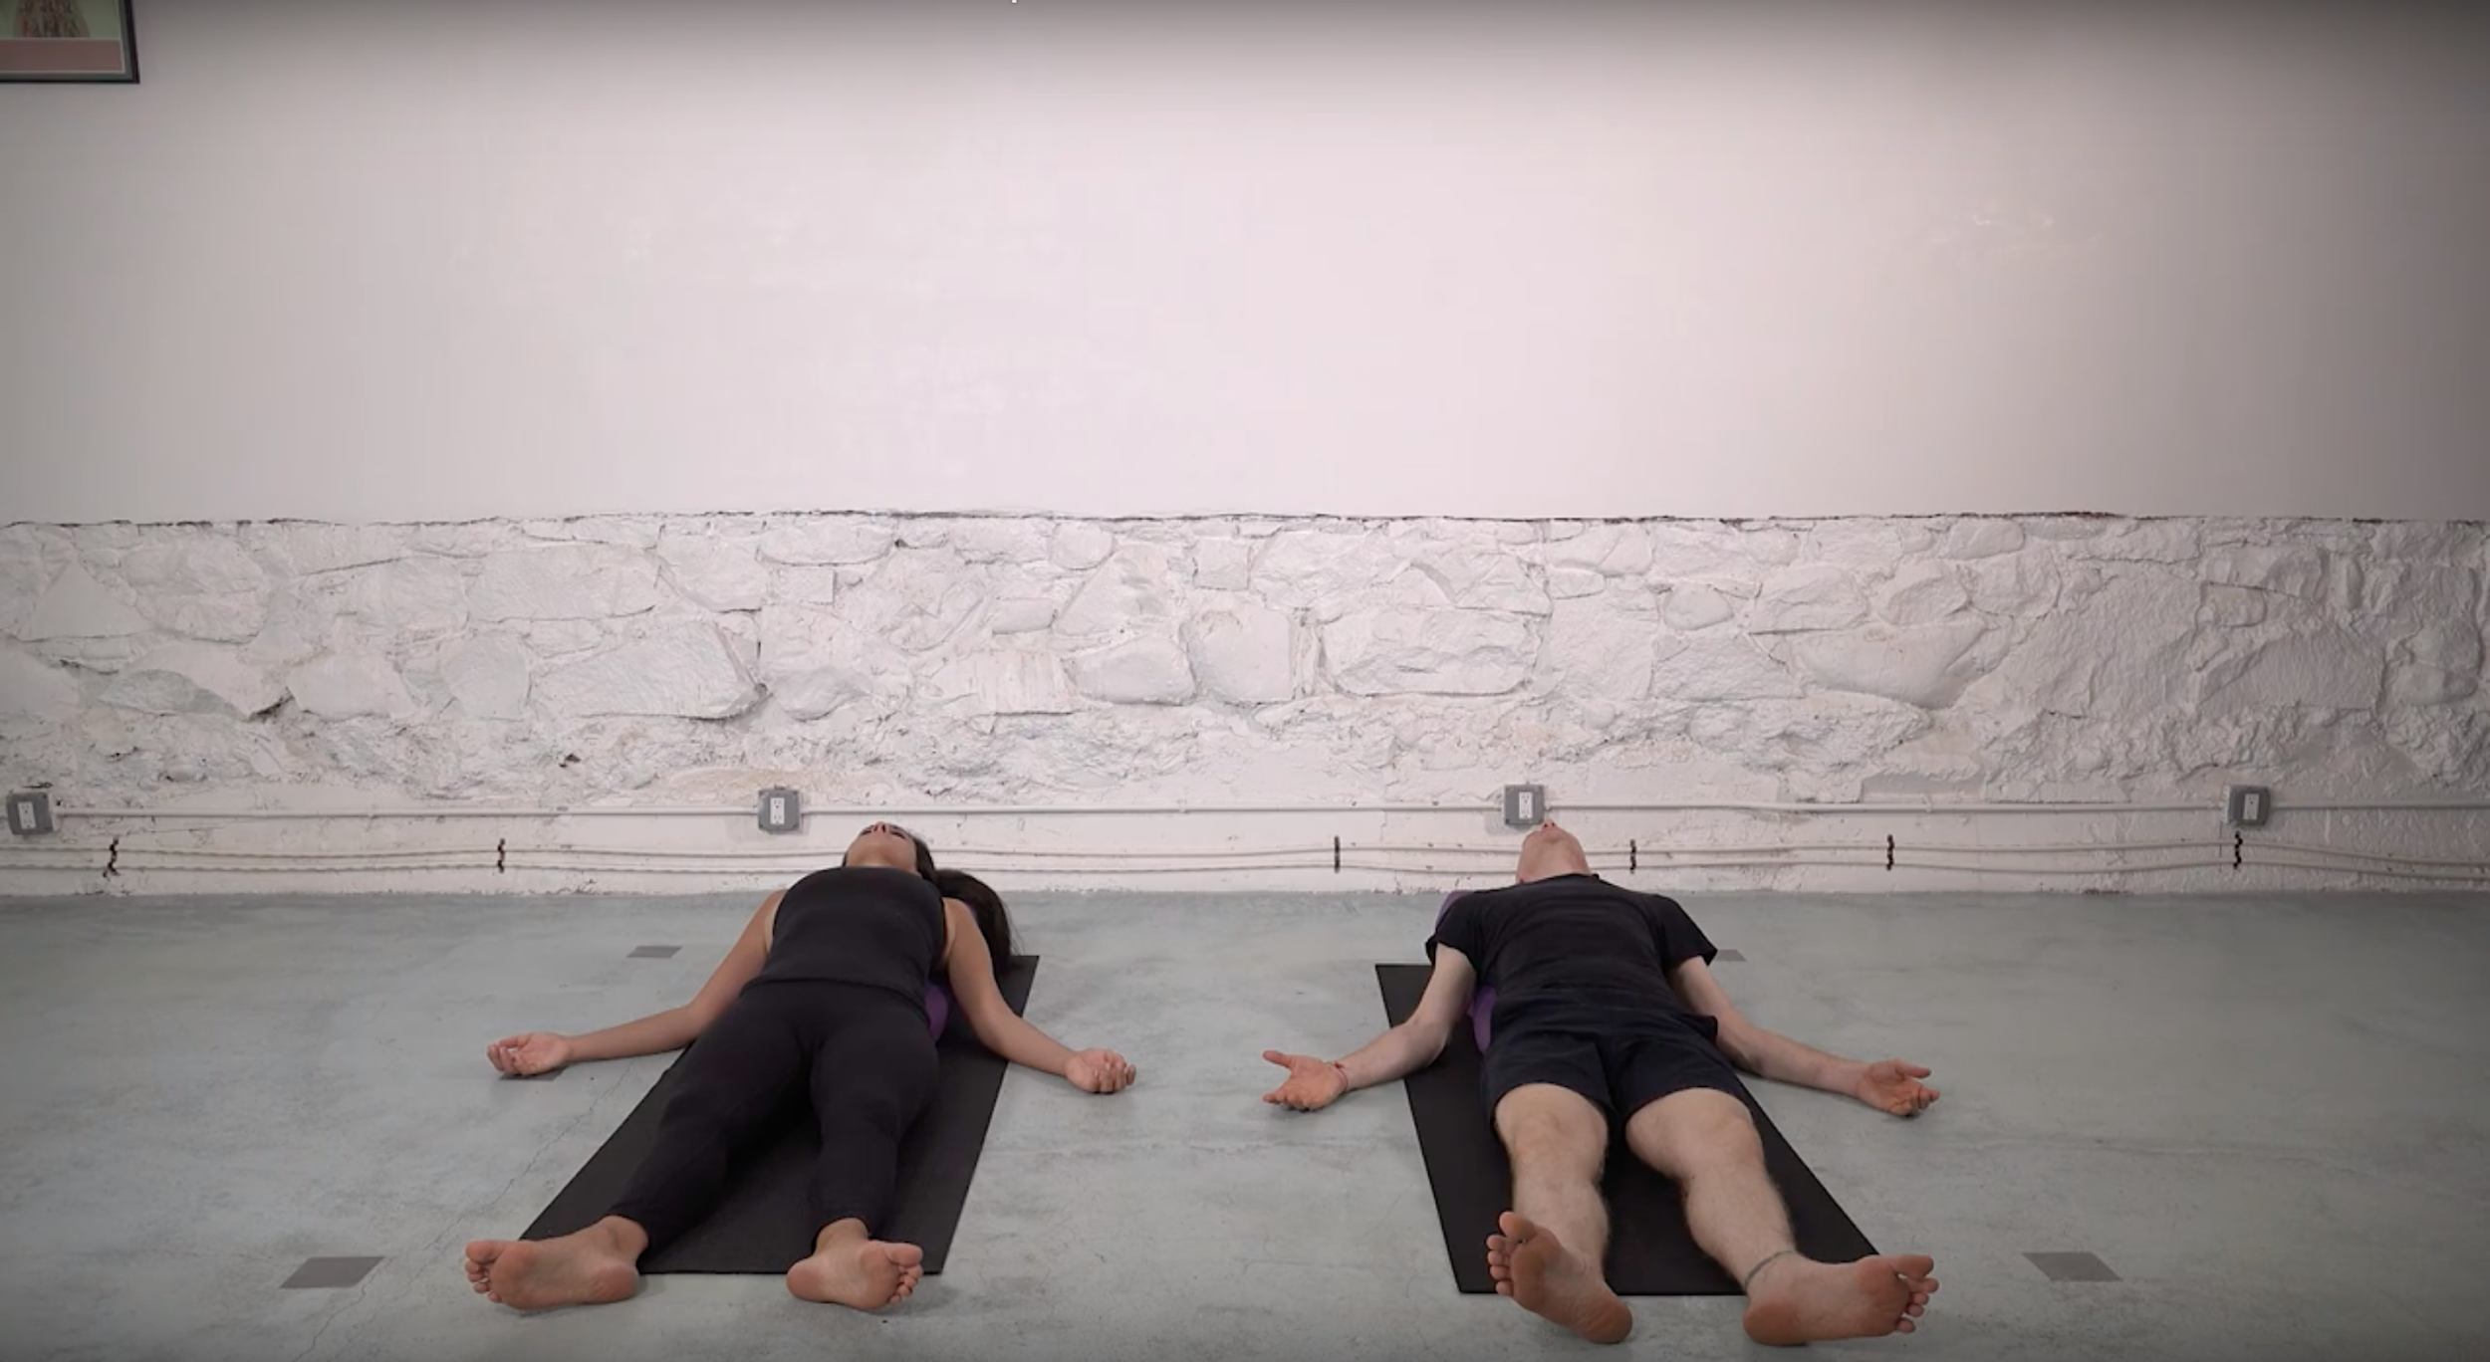

Next you will lay down on your back in the resting pose, where you completely relax every part of your body. This helps to calm and de-stress our body and mind.

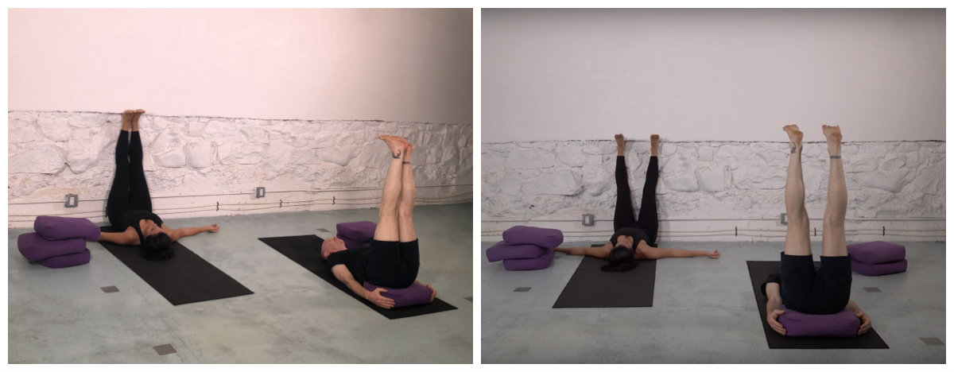

We then move to a supported legs extended pose, which is soothing for the lower back. This can also be done with your legs up a wall, and we demonstrate both versions in the video. The extended leg pose can be done with a pillow under the small of your back for ease and comfort. This practice should help to stabilize your endocrine system, and decrease the impact of long term stress.

# Challenges faced and how those were tackled:

# To complete this course successfully from the month of June 2020 to august 2020 I faced some challenges that are mentioned below along with the solution that heled me to tackle the particular challenge: -

# Challenge 1 – Time management.

# The length of this course is almost 27 hours. in the beginning means in the month of July it was quite easy for me manage my time for this course. But later on, after the commencement of my regular classes I could not arrange my time for this course and I had also registered in some other massive open online courses of different domain.

# Solution 1 –

# The course is of 27 hours and 8 weeks means almost 3.5 hours / week. So, I decided to give at least 30 – 45 minutes daily for this course most probably in the morning before my regular classes. There is feature in coursera that one can reset his deadline if he/she gets late for the particular week. This also a helpful option for me some times.

# Challenge 2 – To understand the concepts from a different domain.

# This course gives an excellent knowledge about sustainability. some new and high-level concepts were also introducing that I could not understand immediately.

# Solution 2 –

# The topics in which I had doubt, I started watching the video sessions again for that part in my weekend. I also started searching about that topic and reading few articles on that. The reading material provided was really helpful to tackle this challenge.

# 

# Challenge 3 – The quizzes and the peer graded assignment.

# In this course every module contains some compulsory quizzes or peer graded assignment. One needs to score at least 75% to pass the particular module but sometimes I could not score 75% in a first attempt.

# Solution 3 –

# Some of the quizzes or assignment. I could not pass in single attempt. For the next attempt I used to prepare more well for the topics that I was weak in. according to coursera policies, one can re - attempt the quiz after some span of time. For the peer graded assignment, I used to read about the topic through articles and reading material. By following this strategy, I cleared all the quizzes and assignments with the eligible score.

**Quizzes with grades:**

* **Practice breakdown quizzes(objective)**

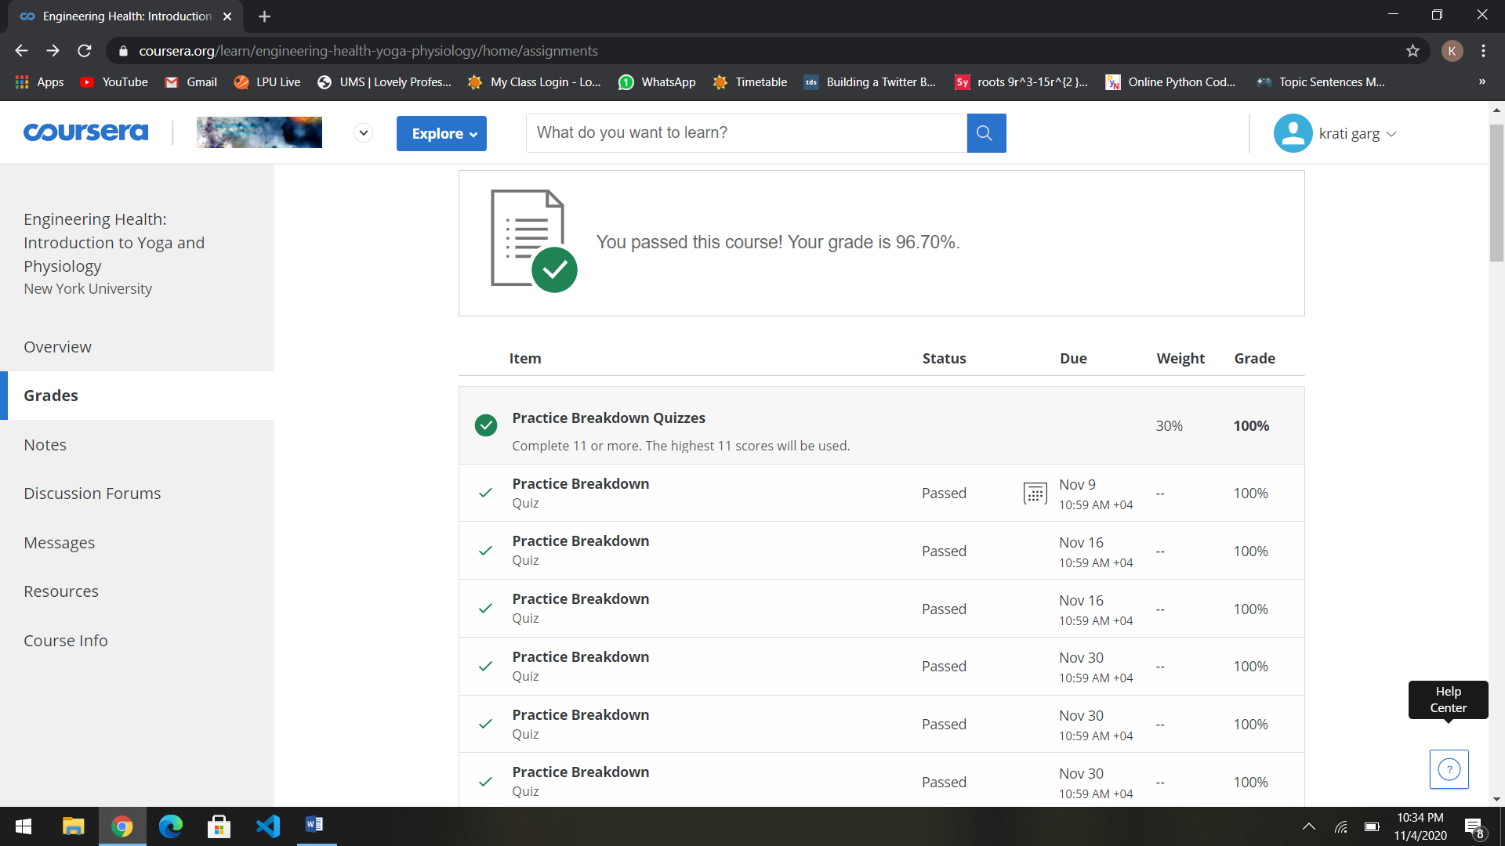

* **Reading quiz questions(subjective)**

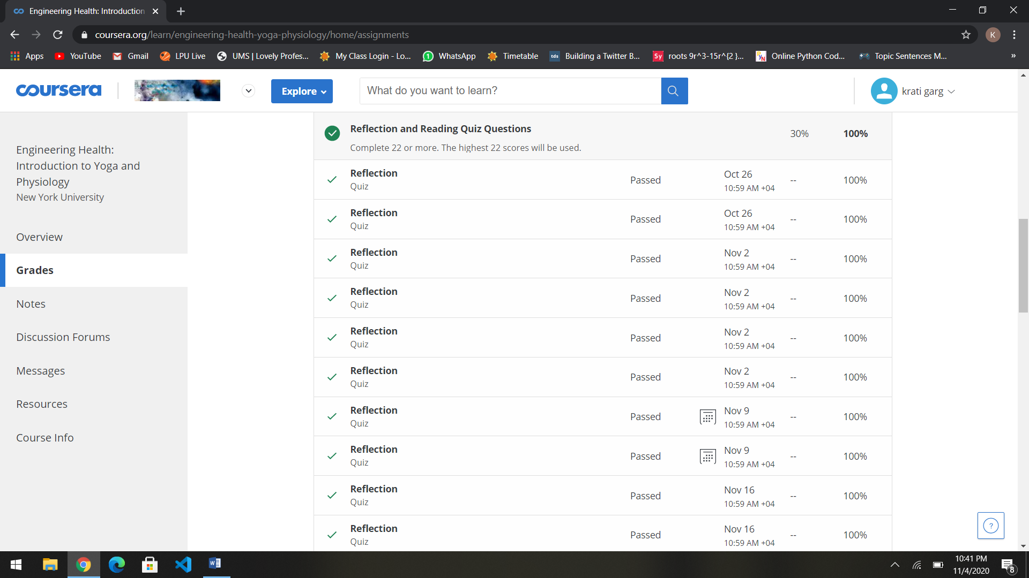

CHAPTER – 4

**Conclusion of the course**

**Brief description:** In this module everything is integrated that we have learned in the previous modules to enhance our overall health and wellness. The focus of this module is on practicing a short but complete practice that can be done on a daily or weekly basis. This yoga practice was designed as part of a hypertension and yoga study, where it was able to reduce hypertension. Being able to integrate this complete practice into our daily lives is a perfect practical summary of everything that has been practiced.

### **Objective:**

### Examine underlying physiological mechanisms that connect healthy functioning to yoga practice.

**Posture breakdown of the comprehensive practice:**

**1. Sun Salutations**

* The sun salutations are a dynamic set of exercises that coordinate breath and movement and warm up the muscles. They improve strength, endurance, and cardiac health.

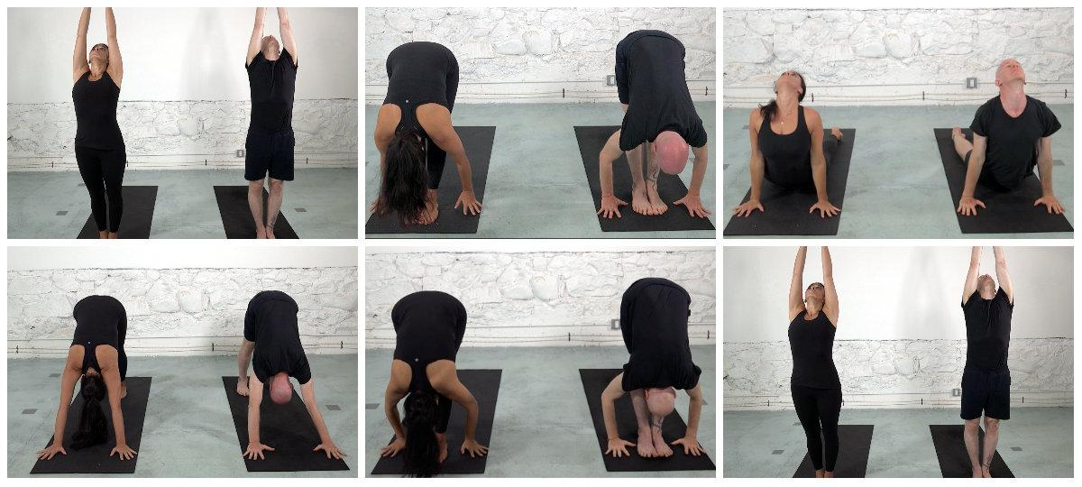

**2. Standing forward bends**

There are two variations of forward bending that we do in this sequence; one holding the big toes, and the other stepping on the hands. These positions stretch the hamstrings, back, and tone the abdominal muscles.

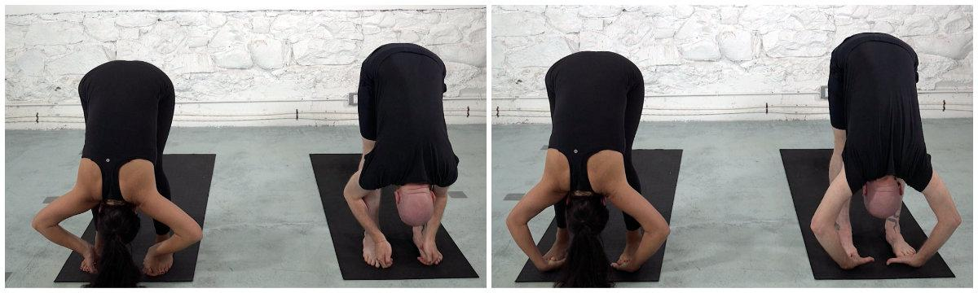

**3. Triangle and Side Angle**

The standing poses strengthen the waist and legs, as well as open the ribcage and the hamstrings. We show two variations on “angle” postures here: the triangle and side-angle.

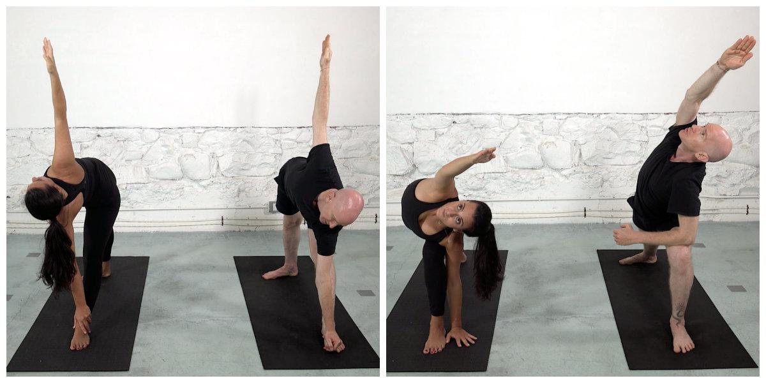

**4. Pyramid Pose**

The pyramid pose opens the legs, lower back, and hips. It is a forward bend over one leg with the hands behind the back, other holding your elbows, or placing the palms together.

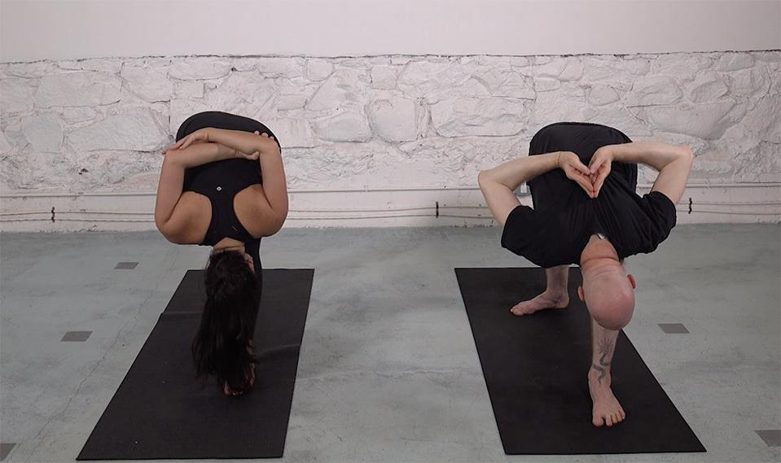

**5. Tree pose and figure 4**

These two balance poses strengthen the sense of proprioception and spatial awareness. The tree pose is one of the most recognizable of all yoga postures. The figure 4 is a slightly more challenging version of the tree pose.

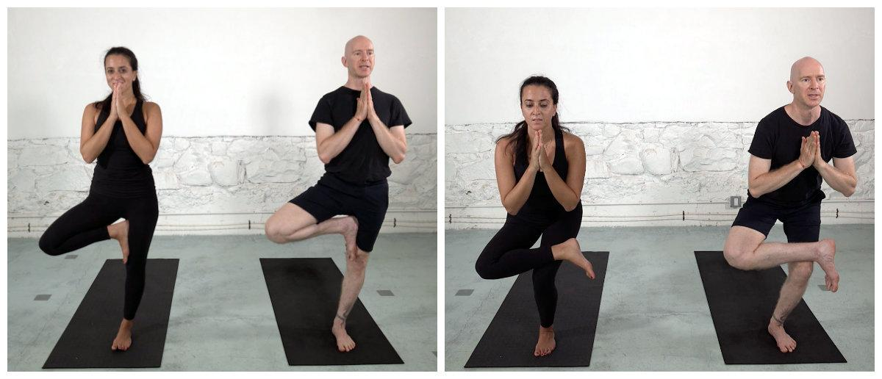

**6. Forward bend and Table top**

Pose and counter-pose are consistent themes that occur in yoga. Here we demonstrate the seated forward bend followed by “table-top”, which taken together move the spine in opposite directions.

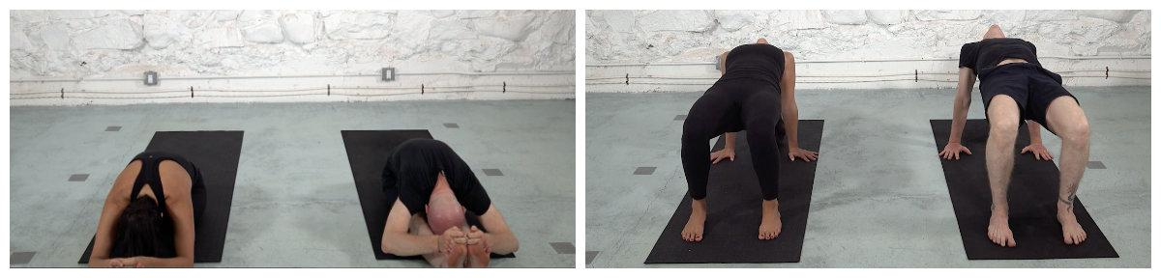

**7. Boat pose**

These variations of the boat pose support the back spinal muscles, as well as the front, lower abdominal muscles.

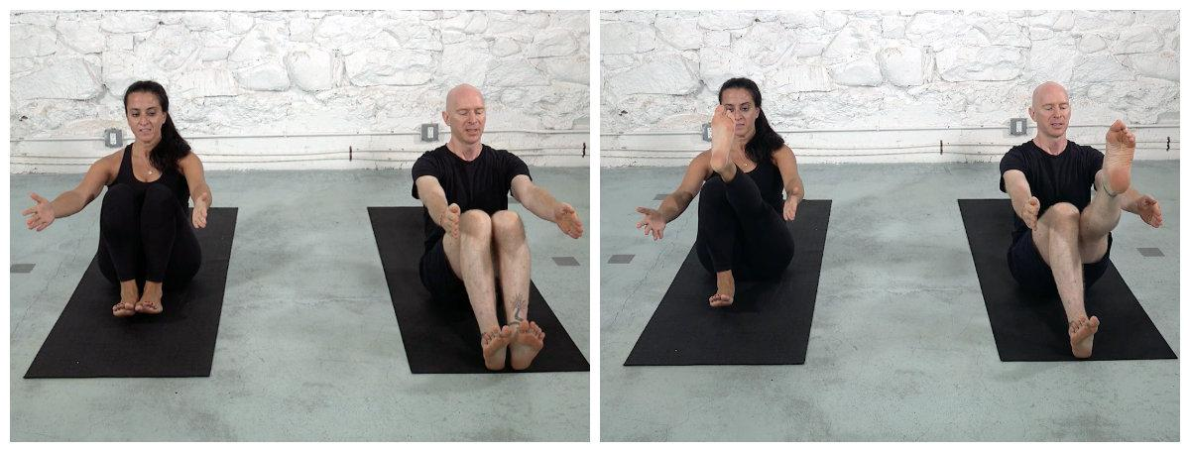

**8. Meditation and final relaxation**

Long, slow, steady breathing balances the branches of the nervous system, and creates a sense of focused awareness in the mind. It is the basis for all mindfulness practices. The relaxation pose can be done lying flat on your back, lying on your back with your knees bent, lying on your side, or even on your belly. This is an important pose: it helps to activate the parasympathetic nervous system, allowing repair and restoration to occur in your body on a cellular level.

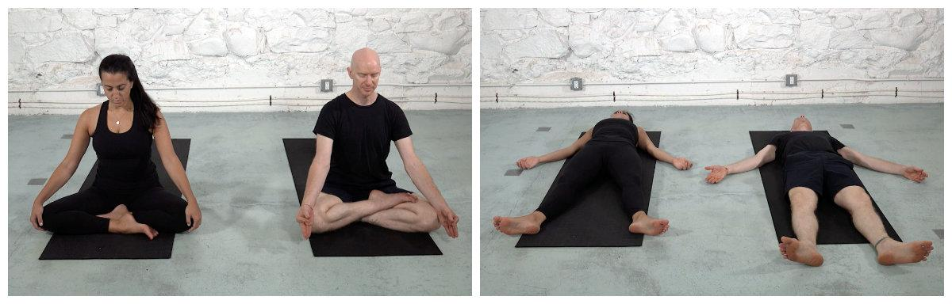

**Conclusion:**  We have learned an extensive amount of information about the different physiological systems, and their associated pathologies. By utilizing a combination of the lectures, readings and interviews, you have been able to accomplish learning an abundance of information regarding the physiological systems and their common pathologies. In addition, we have focused on the implications of stress on overall wellness and pathology, and highlighted the importance of stress reduction techniques. We have also been able to hear first hand from experts in their fields, who endorse stress reduction, pain management, and yoga for a number of pathologies, as well as overall health. The yoga components of the modules have allowed us to explore poses, breathing exercises and sequences to enhance wellness to that system. In addition, the associated quizzes were utilized to reinforce the concepts from a basic physiological concepts, as well as the yoga practices.

**References**

* [**https://www.coursera.org/learn/engineering-health-yoga-physiology/home/welcome**](https://www.coursera.org/learn/engineering-health-yoga-physiology/home/welcome)
* [**https://en.wikipedia.org/wiki/Main_Page**](https://en.wikipedia.org/wiki/Main_Page)
* [**https://www.coursera.org/learn/engineering-health-yoga-physiology/home/welcome**](https://www.coursera.org/learn/engineering-health-yoga-physiology/home/welcome)
* [**https://www.youtube.com/watch?v=EB0_9D5h_oE**](https://www.youtube.com/watch?v=EB0_9D5h_oE)
* [**https://www.youtube.com/watch?v=bxA9lkyEVKQ**](https://www.youtube.com/watch?v=bxA9lkyEVKQ)